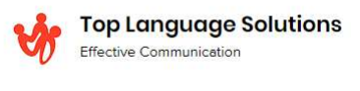
Compliance 2026

Interpreter´s Name:

Interpreter´s ID:

I have successfully completed Propio LS, LLC's Remote Services
Orientation Refresher and Compliance Training, which includes but is not limited to: Interpreter
Code of Ethics & Standards of Practice, General Compliance, CMS Fraud, Waste & Abuse, Patient
Confidentiality and HIPAA Compliance, Harassment & Discrimination, and company policies and
procedures.

Digital Signature:

Date Completed: MM/DD/2026

